1. Write a Python program to create a class representing a Circle. Include methods to calculate its area and perimeter.

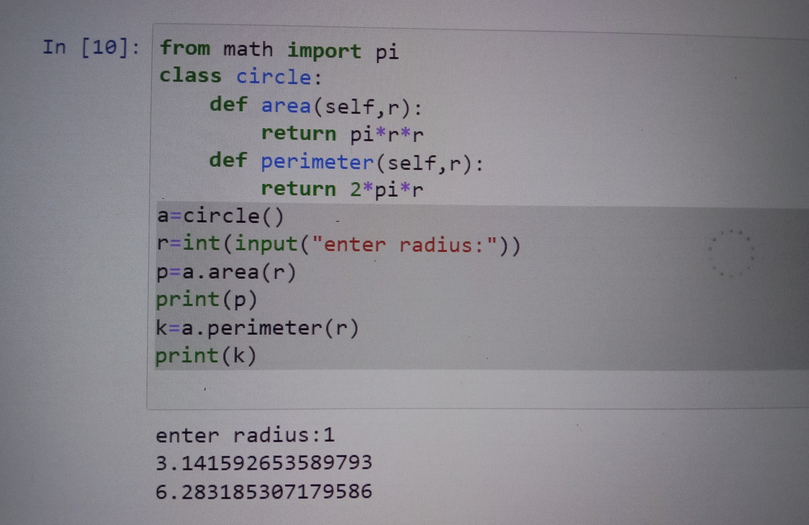

2. Write a Python program to create a calculator class. Include methods for basic arithmetic operations.

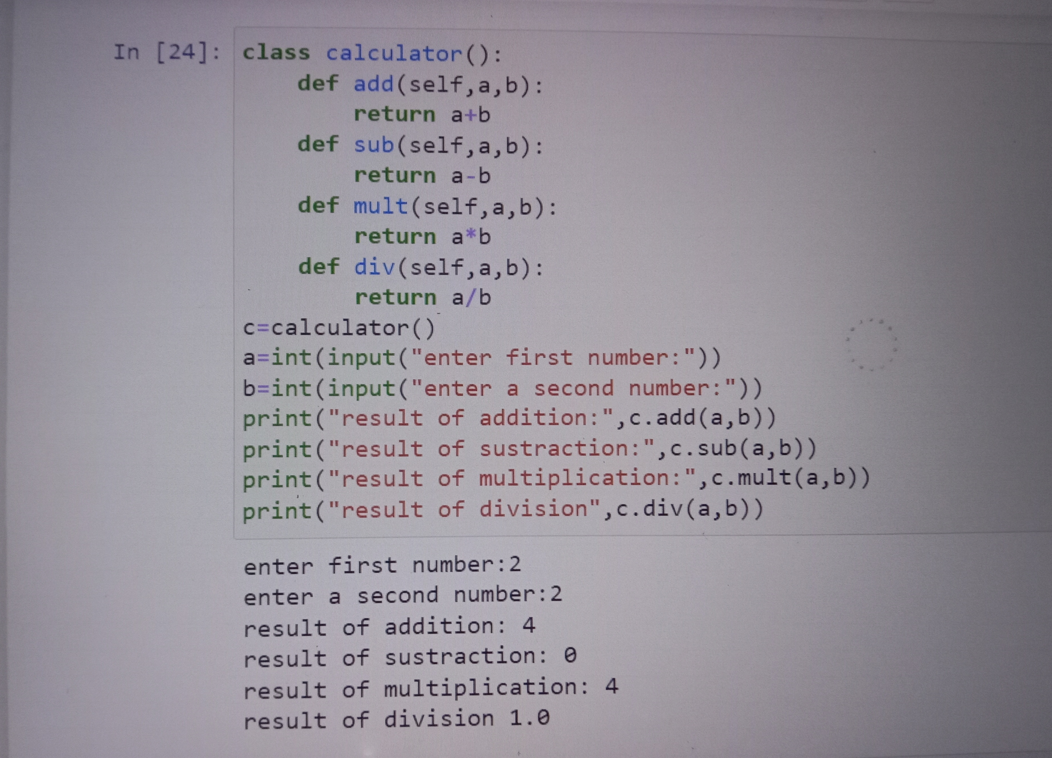

3. Write a Python program to create a class that represents a shape. Include methods to calculate its area and perimeter. Implement subclasses for different shapes like circle, triangle, and square.

